**Next-Generation EMR: Harnessing Voice Input and AI for Real-Time Clinical Guidance**

**A MINI PROJECT REPORT**

***Submitted by***

**Sre Varsha. N 230701330**

**Niranjana. K 230701400**

***In partial fulfilment for the requirement of award of the degree***

***of***

**BACHELOR OF ENGINERRING**

***in***

**COMPUTER SCIENCE AND ENGINEERING**



**RAJALAKSHMI ENGINEERING COLLEGE (AUTONOMOUS)**

**THANDALAM CHENNAI – 602105**

**May 2025**

**BONAFIDE CERTIFICATE**

Certified that this Thesis “**Next-Generation EMR: Harnessing Voice**

**Input and AI for Real-Time Clinical Guidance**” is the Bonafide work of

**Sre Varsha N (230701330)**, **Niranjana K (230701400)** who carried out the

work under my supervision. Certified further that to the best of my knowledge

the work reported herein does not form part of any other thesis or dissertation

on the basis of which a degree or award was conferred on an

earlier occasion on this or any other candidate.

Student Signature with Name

1.

2.

3.

Signature of the Supervisor with date

Signature Examiner-1 Signature Examiner-2

**ABSTRACT**

A new EMR (Electronic Medical Record) system has been designed to make healthcare processes more efficient and help with making better decisions. (1) With voice-input prescriptions, clinicians can simply speak their prescriptions, making it easier and more accurate for patients’ information to be handled. (2) With Clinical Decision Support Systems (CDSSs), the system gives doctors useful advice at the moment, guided by the input from the patient. Modules built in Flutter make the app interface easy to use, and Flask manages the requests and handles data tasks well. The company uses Google Cloud Speech-to-Text to turn voice recordings into text, and it uses Firebase Firestore to manage patient data safely. Machine learning models in Python are also added by the system, using scikitlearn, TensorFlow, and PyTorch. With these models, patient information is analyzed to give doctors personalized advice, assess risks, and send immediate alerts, so they can make good decisions in real time. The system is designed to handle an increasing workload and to safeguard patient data. The transcription module correctly identifies 95% of commonly used medical terms and the CDSS models maintain an accuracy of 86%. This level of performance ensures that clinical data is both precise and actionable. The EMR system also supports multilingual transcription and translation to serve patients from diverse backgrounds, while secure APIs enable integration with external healthcare services for better data sharing. Advanced encryption techniques protect patient data at every stage, and the cloud-based design allows for fast deployment and easy updates. With robust logging and audit trails for every action, the system ensures transparency and reliability, contributing to smoother and more informed decision making for healthcare providers.

**TABLE OF CONTENTS**

|  |  |  |
| --- | --- | --- |
| **Chapter No.** | **Title**  Abstract  Table Of Contents  List Of Figures | **Page No**.  iii  iv  v |
| 1  1.1  1.2 | Introduction  Design Thinking Approach  Stanford Design Thinking Model | 1  2  3 |
| 2 | Literature Review | 7 |
| 3 | Domain Area | 8 |
| 4 | Empathize | 9 |
| 5 | Define Stage | 11 |
| 6 | Ideation Stage | 12 |
| 7 | Prototype Stage | 14 |
| 8 | Test and Feedback | 23 |
| 9 | Re-Design and Implementation | 26 |
| 10 | Conclusion | 27 |
| 11 | Future Work | 28 |
| 12 | Learning Outcome  References | 28  29 |

**LIST OF FIGURES**

|  |  |  |
| --- | --- | --- |
| **Figure No.** | **Title** | **Page No.** |
| 1 | Ideation Mind Map | 14 |
| 2 | System Architecture | 15 |
| 3 | Login Page | 18 |
| 4 | Dashboard Page | 18 |
| 5 | Patient Profile Page | 19 |
| 6 | Transcription Page | 19 |
| 7 | Patient Transcripts Page | 20 |
| 8 | CDSS Input Page | 21 |
| 9 | CDSS Output Page | 22 |

1. **Introduction**

Electronic Medical Records (EMRs) are now crucial components of the modern healthcare system, facilitating the ease of combining patient information for enhanced management efficiencies. Despite this, most current systems still depend largely on manual data entry processes, whose nature is inherently time-consuming and error-prone. Healthcare providers are frequently exposed to overwhelming administrative tasks, diverting their attention from face-to-face patient contact, thus resulting in inefficiencies and possible drawbacks in the quality of patient care. Further, the lack of real-time, sophisticated decision support systems can hinder effective clinical judgments, thereby compromising the quality of care provided. This paper presents a solution to such problems through the integration of two emerging technologies: prescription input through voice control and an artificial intelligence-based Clinical Decision Support System (CDSS). The voice input feature allows clinicians to prescribe directly, not just saving time in manual entry but also eliminating transcription errors. The feature allows healthcare professionals to spend more time with patients, enhancing the quality of care. The AI-driven CDSS, on the other hand, calculates clinician inputs to produce real-time, evidence-based recommendations, augmenting clinical decision-making with contextual information.

The key objectives of this project are to streamline clinical workflows by reducing the requirement for manual voice entry of data through voice-enabled prescription input, enhance efficiency, and eliminate transcription errors. In addition, it is also intended to enable enhanced clinical decision-making through an artificial intelligence-powered environment that delivers real-time, actionable suggestions to enable informed decision-making from data for clinicians. However, the project is intended to build a cross-platform electronic medical records app with an easy-to-use interface built with Flutter supported by a fault-tolerant backend using Flask, Google Cloud Speech-to-Text to enable accurate voice transcription, and Firebase Firestore for secure, low-latency data management, thereby ensuring reliable performance under real-time clinical scenarios

**1.1. Design Thinking Approach**

Design Thinking has emerged as a powerful, human-centered methodology for addressing complex challenges, especially in fields like healthcare where solutions must be deeply aligned with user needs. By prioritizing empathy, creativity, and iterative refinement, Design Thinking enables the development of technologies that are not only functional but also intuitive and impactful in real-world clinical settings.

At its foundation, Design Thinking is an iterative, non-linear process that focuses on creating meaningful and practical solutions. The methodology revolves around five essential phases:

* **Empathize**: Develop a deep understanding of the users—healthcare professionals and patients—by observing, engaging, and empathizing with their experiences, pain points, and workflows.
* **Define**: Synthesize the insights gathered to clearly articulate the core problems to be addressed, framing them in a user-centered context.
* **Ideate**: Encourage divergent thinking and collaborative brainstorming to explore a broad spectrum of potential solutions without constraints.
* **Prototype**: Translate ideas into tangible models or mockups that can be quickly tested, enabling the exploration of various functionalities and interfaces.
* **Test**: Engage users in evaluating the prototypes, gather actionable feedback, and iterate upon the solution to better meet user expectations and real-world demands.

In the healthcare domain, where technology can significantly influence patient care and clinician efficiency, Design Thinking ensures that innovations are not only technically robust but also empathetically designed and clinically relevant.

#### Key Models of Design Thinking:

Several established frameworks guide the application of Design Thinking, each offering unique perspectives on innovation:

* **Stanford Design Thinking Model**: Perhaps the most widely referenced, this model encompasses the five foundational stages—Empathize, Define, Ideate, Prototype, and Test. It emphasizes a deep understanding of users as the basis for generating and refining creative, user-centric solutions.
* **Double Diamond Model (Design Council UK)**: This model organizes the process into four phases: Discover, Define, Develop, and Deliver. Its strength lies in its structured divergence and convergence approach, encouraging teams to fully explore the problem space before narrowing in on a precise, well-defined solution.
* **IBM Design Thinking Framework**: Integrating principles of agile development, IBM’s model focuses on collaborative iteration and rapid feedback. It promotes continuous user engagement throughout the product lifecycle, making it particularly effective for dynamic environments like healthcare, where user needs frequently evolve.

Each of these models underscores the core values of empathy, experimentation, and continuous improvement. By applying Design Thinking in the context of healthcare technology development, solutions can be created that not only meet clinical requirements but also resonate with the day-to-day realities of users—ultimately driving adoption and improving outcomes.

**1.2. Stanford Design Thinking Model and Its Phases**

The **Stanford Design Thinking Model** is among the most widely adopted frameworks for tackling complex, human-centric problems. Especially relevant in fields such as healthcare and technology, this model guides interdisciplinary teams through a structured, empathetic, and iterative process aimed at developing solutions that are both innovative and deeply aligned with end-user needs.

This methodology is broken down into **five distinct phases**—each contributing to the creation of meaningful and impactful solutions. When applied to the development of Electronic Medical Records (EMR) systems, this model helps ensure that the final product addresses real challenges experienced by healthcare professionals in clinical settings.

**1.2.1. Empathize: Understanding User Needs**

The first and arguably most important step in the Design Thinking process is empathy. Before writing any code or proposing solutions, we spent time understanding how clinicians interact with existing EMR systems—what works, what doesn’t, and where the real frustrations lie.

This phase began with **in-depth interviews** with doctors, nurses, and administrative staff from a variety of healthcare settings. These conversations revealed a consistent theme: existing EMR platforms often felt like more of a burden than a help. Clinicians talked about repetitive data entry, systems that required too many clicks to access basic information, and the sheer mental load of multitasking between patient care and documentation.

To complement these interviews, we conducted **on-site observations**, watching as healthcare professionals used EMRs during their actual workflows. This helped us capture not only what users said, but what they did—small pauses, workarounds, or moments of visible frustration that pointed to deeper usability issues. For instance, we noticed that many physicians would scribble notes on paper during consultations, intending to enter them into the EMR later, simply because the software was too slow or cumbersome to use in real-time.

We also carried out **secondary research**, including academic papers, product reviews, and case studies of EMR implementation failures and successes. This helped us identify broader trends—such as the growing need for mobile accessibility, integration with diagnostic tools, and decision support features—and how those trends intersected with user pain points.

Through this immersive process, we built empathy not just with users’ functional needs, but with their daily realities: time pressures, cognitive load, and emotional investment in patient care. This understanding formed the foundation of our design approach.

* + 1. **Define: Framing the Problem**

With a solid understanding of the user landscape, the next step was to turn those insights into a clear, focused problem statement. While it might be tempting to solve every issue at once, successful innovation often begins with narrowing the scope.

Our observations and interviews made it clear that two major issues stood out: **manual data entry** and **lack of intelligent support** during decision-making. Many clinicians found it tedious and error-prone to type out prescriptions or navigate complex menus. Additionally, they often lacked timely, personalized recommendations based on patient history, lab reports, or potential drug interactions.

**We framed our design challenge accordingly:**

“How might we create an EMR system that reduces manual data entry through voice interaction while offering real-time, AI-driven decision support to assist clinicians at the point of care?”

This problem definition kept us grounded. It gave us direction without limiting creativity and helped align all subsequent design and development efforts with actual user needs.

* + 1. **Ideate: Generating Creative Solutions**

With a clear problem in hand, we moved into ideation—an open-ended, creative phase focused on generating as many potential solutions as possible. At this stage, no idea was too wild or impractical. We encouraged blue-sky thinking, especially from those not directly involved in development, such as junior medical staff or patients, to surface fresh perspectives.

We hosted **brainstorming sessions** where cross-disciplinary team members—designers, developers, healthcare professionals—pitched ideas ranging from smart voice assistants to wearable devices that could auto-log patient metrics. We also explored how the system could use **predictive analytics** to assist with clinical decisions, or how **machine learning** could personalize user interfaces based on usage habits.

These sessions were followed by **collaborative sketching**, where rough wireframes and diagrams gave form to promising ideas. We grouped concepts thematically—voice-based input, AI decision support, mobile optimization—and began to assess each idea’s technical feasibility, user impact, and alignment with our core problem.

The result was a refined list of ideas that felt ambitious yet attainable:

* A **voice-enabled prescription entry** interface powered by real-time speech recognition.
* An **AI-powered Clinical Decision Support System (CDSS)** trained on large medical datasets.
* A **mobile-first interface** using Flutter for cross-platform compatibility.
  1. **. Prototype: Bringing Ideas to Life**

With our top ideas selected, we began building low-fidelity prototypes—not polished software, but **testable models** that allowed us to explore layout, flow, and user experience.

We created **clickable wireframes** for the mobile app, showcasing how users might log in, dictate prescriptions, receive alerts, or access patient history. For the voice module, we developed a basic prototype using Google’s Speech-to-Text API integrated with a simple text editor, simulating the act of dictating prescriptions in real-time.

At this stage, **rapid iteration** was key. We regularly reviewed prototypes with our clinical partners, who offered invaluable feedback. For example, one physician noted that transcription should pause automatically when silence is detected—a small but crucial detail that we hadn’t considered.

We also prototyped the backend logic for the CDSS, testing how it could flag allergic reactions or suggest dosages based on prior cases. Although these features were in their infancy, prototyping allowed us to explore what was possible and prioritize the most impactful functionalities.

**1.4. Test: Validating with Real Users**

Testing was the final—and most illuminating—phase of the Design Thinking cycle. We returned to our users, this time armed with interactive prototypes and functional demos, and asked them to engage with the system in a controlled yet realistic setting.

Through **user testing sessions**, clinicians interacted with the prototype as if they were in a real consultation. We recorded how quickly they completed tasks, how often they relied on voice input, and whether the CDSS alerts were understood and acted upon.

We combined **qualitative feedback** (through interviews) with **quantitative metrics** (such as task time and error rates) to assess performance. One major insight from testing was that users preferred a simple interface with fewer on-screen distractions—a discovery that led us to further streamline our design.

Feedback also revealed that while users appreciated the CDSS, they wanted the option to **override suggestions** or mark them as irrelevant—an essential reminder that AI should assist, not dictate, in clinical contexts.

**2. Literature Review**

Zhang and Chang et al. [1] introduced a semi-supervised learning framework to enhance patient data clustering in Chinese EMRs. While their method improved clustering performance, it did not include real-time transcription or decision support, limiting its practical applicability in clinical settings. In contrast, the system discussed in this paper integrates voice transcription into the EMR, enabling real-time, detailed clinical narratives that are instantly available for decision-making.

Similarly, Gil et al. [2] developed a recommendation system that linked patient records with continuing medical education (CME) data. While this system offered useful recommendations, it lacked real-time, contextual integration for decision support during clinical encounters. The CDS in this paper, however, delivers actionable, evidence-based recommendations in real-time, directly improving clinical decision-making.

Abidi et al. [3] developed the Personalized Healthcare Information Dissemination System (PHIDS), which customized health information for patients. However, it did not focus on supporting clinicians in decision-making, which limits its relevance in clinical practice. In contrast, the system in this paper provides personalized decision support tailored to clinicians, significantly enhancing patient care in real-time.

Bates et al. [4] emphasized the need for timely and contextually relevant CDS but did not integrate voice transcription for hands-free data entry. This gap is addressed by the system proposed in this study, which combines voice-enabled input with real-time decision support to ensure recommendations are delivered exactly when they are needed.

Valdez et al. [5] highlighted barriers to the adoption of recommender systems in healthcare, including complexity and a lack of clinician trust. Their system did not incorporate real-time decision support or integration with clinical workflows. The system discussed here focuses on clinician engagement and usability, ensuring that the system is intuitive, reliable, and well-integrated into clinical practice.

Anibal et al. [6] introduced the Voice EHR system, leveraging multimodal audio data for health applications to improve clinical decision-making. Their work highlighted the challenges of deploying AI models trained on high-quality audio data in resource-limited settings, emphasizing the need for scalable solutions to enhance health equity.

Wong et al. [7] explored the use of machine learning to identify health outcomes from electronic health record (EHR) data. Their review discussed common challenges in

creating computable phenotyping algorithms and highlighted four critical scenarios where machine learning can effectively support health outcome identification.

Ford et al. [8] conducted a systematic review on extracting information from electronic medical records (EMRs) to improve case detection. They highlighted that relying solely on structured codes can bias results and miss cases, emphasizing the potential of incorporating unstructured text data to enhance the accuracy and quality of research.

Xia et al. [9] developed an online electronic medical record (EMR) system using speech recognition to reduce the manual data entry burden on healthcare workers. Their system integrates medical linguistic knowledge, personalized acoustic models, and multi-accent adaptation, significantly improving efficiency and accuracy compared to traditional keyboard-based EMR systems.

Saha et al. [10] examined the advancement of electronic patient record systems, focusing on the increasing expenses related to personnel and record management. Their work highlighted the promising role of voice-activated clinical reporting systems and portable data management devices in reducing costs, improving data accessibility, and supporting more efficient clinical decision-making.

**3. Domain Area: Healthcare Technology and EMR Systems**

The integration of advanced digital technologies into healthcare is reshaping the management and accessibility of patient information. Among these innovations, the adoption of Electronic Medical Records (EMR) systems marks a significant step toward modernizing clinical workflows. EMR systems are designed to replace conventional paper-based documentation with digital records, offering numerous advantages such as streamlined access to patient history, improved care coordination, enhanced data security, and support for real-time clinical decisions.

Despite these benefits, the shift to EMR has surfaced a number of operational challenges. Many systems still rely heavily on manual data entry, which is prone to errors and can lead to inefficiencies in clinical documentation. Additionally, time-consuming interfaces and the absence of robust Clinical Decision Support (CDS) tools often hinder real-time decision-making and affect the quality of care delivery.

This project aims to overcome these limitations by integrating two key technologies - Clinical Decision Support (CDS) and voice transcription into existing EMR platforms. CDS systems empower healthcare professionals with timely, evidence-based guidance during patient interactions, thereby supporting more informed and accurate decisions. Simultaneously, voice transcription streamlines data entry by allowing clinicians to dictate notes, reducing their dependence on traditional keyboard inputs. Together, these enhancements are expected to improve data accuracy, optimize clinical efficiency, and ultimately contribute to better healthcare outcomes and provider satisfaction.

**4.** **Empathize Stage: Understanding User Needs**

The **Empathize** stage is pivotal in the design thinking process, helping to gain a deep understanding of the user's challenges and experiences. In the context of this project, the primary users are healthcare professionals interacting with Electronic Medical Record (EMR) systems. Given the time limitations and challenges in accessing clinical environments for direct interviews, this stage utilized secondary research methods and hypothetical observation scenarios to gather user insights.

**Activities Conducted:**

To effectively identify and understand the critical pain points associated with EMR usage, the following activities were undertaken:

* **Review of Case Studies and Academic Literature:** A detailed review of case studies and research papers provided valuable insights into the practical challenges encountered by healthcare professionals during EMR adoption. These sources highlighted issues related to usability and data entry that often go unaddressed in commercial evaluations of EMR systems.
* **Observation of Product Demonstrations and Usage Videos:** By observing product demonstrations and real-world usage videos, a more hands-on understanding of EMR system interfaces and workflows was achieved. This method allowed for direct insight into how healthcare professionals interact with EMR systems, the challenges they face, and areas for improvement.
* **Analysis of User Feedback from Digital Platforms:** Feedback from digital platforms such as Capterra, TrustRadius, and healthcare forums was reviewed to capture real-world perspectives. These platforms feature ratings and reviews from healthcare professionals who use EMR systems daily, offering valuable insights into common challenges that often go unnoticed in traditional research papers.

### Key Findings:

Through interviews, hands-on observations, and supporting research, several core issues emerged that consistently hinder the effective use of EMR systems in real clinical environments. These aren’t just technical challenges—they reflect the real frustrations and constraints faced by doctors, nurses, and healthcare staff who rely on these systems daily to provide patient care. Understanding these pain points helps shape better, more intuitive tools that align with the realities of clinical work.

1. **Voice-Activated Data Entry:** One proposed solution was the integration of voice-activated transcription into EMR systems. This feature would allow healthcare professionals to dictate patient information into the system, enabling them to document medical records hands-free. The integration of voice recognition technology would save valuable time and significantly reduce the likelihood of manual data entry errors, thus allowing professionals to spend more time with patients.
2. **Real-Time Clinical Decision Support (CDS):** Another idea was to integrate clinical decision support directly into the EMR system. This feature would provide real-time, evidence-based recommendations to healthcare professionals during patient care. By analyzing patient data, medical history, and current symptoms, the system could offer personalized treatment options, alerts about potential drug interactions, and reminders for preventive care measures, improving decision-making and enhancing patient safety.
3. **AI-Based Alerts for Treatment Recommendations and Risk Assessments:** In addition to CDS, the integration of artificial intelligence (AI) was proposed to further enhance decision-making. AI algorithms could analyze patient data and provide predictive insights to identify patients at risk of certain conditions, suggest personalized treatment plans, and generate automated alerts for clinical teams. This could help in early detection of health risks and improve the accuracy of treatment plans.
4. **Cloud-Based Secure Storage:** Another idea was to incorporate cloud technology into the EMR system for secure, centralized storage of patient records. Cloud storage would enable healthcare professionals to easily access patient data from any location, facilitating better collaboration between healthcare providers. It would also reduce data silos, enhance data sharing across systems, and ensure secure storage and retrieval of sensitive patient information.

**5. Define Stage: Analyzing User Needs**

Based on the insights obtained during the **Empathize** stage, several critical pain points were identified that healthcare professionals face when using current **Electronic Medical Record (EMR)** systems. These pain points primarily revolve around inefficiencies in data entry, the absence of real-time clinical decision support, and the lack of user-friendly interfaces. The **Define** stage involves synthesizing these insights and creating clear **problem statements** that will drive the design and development of solutions to address these challenges.

**Problem Statements:**

Several core issues were identified that reflect the major barriers to optimal EMR usage. These issues, distilled from the findings of the **Empathize** stage, are as follows:

1. **Doctors Face Delays in Patient Care Due to Inefficient Record-Keeping:**  
   The most pressing issue reported by healthcare professionals is the amount of time spent on manual data entry into EMR systems. Healthcare professionals expressed frustration that this time-consuming process reduces the time available for direct patient care. In busy clinical environments, delays caused by inefficient record-keeping can impede the timely delivery of necessary treatments or consultations.
2. **Existing EMR Systems Lack User-Friendly, Voice-Based Data Entry Features:**  
   A significant challenge is the lack of intuitive user interfaces in many existing EMR systems. Healthcare professionals struggle with navigating complex interfaces that require them to input detailed information manually. There is a need for a more efficient, hands-free solution for data entry, such as voice-activated transcription, that would allow healthcare providers to document patient information quickly without interrupting their workflow.

**Selected Problem Statement:**

After careful consideration, the most pressing problem identified was:  
**"Doctors face delays in patient care due to inefficient manual record-keeping and lack of real-time decision support."**

This problem encapsulates the core issue: time inefficiencies caused by manual data entry processes, combined with the lack of real-time clinical decision support. These challenges hinder healthcare professionals' ability to provide timely care, which directly impacts patient outcomes in clinical settings.

**6. Ideation Stage: Brainstorming Solutions**

The **Ideation** stage focused on generating creative and innovative solutions to address the challenges identified in the **Define** stage. During this phase, a variety of potential ideas were proposed, incorporating both technological advancements and the practical needs of healthcare professionals. The goal was to generate solutions that would alleviate the pain points associated with **Electronic Medical Record (EMR)** systems.

**Ideas Generated:**

Several ideas were brainstormed to improve the functionality and user experience of EMR systems. These ideas were aimed at enhancing efficiency, reducing errors, and improving the overall quality of care in healthcare settings.

1. **Voice-Activated Data Entry:** One proposed solution was the integration of voice-activated transcription into EMR systems. This feature would allow healthcare professionals to dictate patient information into the system, enabling them to document medical records hands-free. The integration of voice recognition technology would save valuable time and significantly reduce the likelihood of manual data entry errors, thus allowing professionals to spend more time with patients.
2. **Real-Time Clinical Decision Support (CDS):** Another idea was to integrate clinical decision support directly into the EMR system. This feature would provide real-time, evidence-based recommendations to healthcare professionals during patient care. By analyzing patient data, medical history, and current symptoms, the system could offer personalized treatment options, alerts about potential drug interactions, and reminders for preventive care measures, improving decision-making and enhancing patient safety.
3. **AI-Based Alerts for Treatment Recommendations and Risk Assessments:** In addition to CDS, the integration of artificial intelligence (AI) was proposed to further enhance decision-making. AI algorithms could analyze patient data and provide predictive insights to identify patients at risk of certain conditions, suggest personalized treatment plans, and generate automated alerts for clinical teams. This could help in early detection of health risks and improve the accuracy of treatment plans.
4. **Cloud-Based Secure Storage:** Another idea was to incorporate cloud technology into the EMR system for secure, centralized storage of patient records. Cloud storage would enable healthcare professionals to easily access patient data from any location, facilitating better collaboration between healthcare providers. It would also reduce data silos, enhance data sharing across systems, and ensure secure storage and retrieval of sensitive patient information.

**Selected Idea:**

After careful evaluation, the most promising solution selected was the integration of a **voice-assisted EMR system** with **real-time clinical decision support**. This combination addresses the core challenges of inefficient manual data entry and the lack of timely decision support in existing systems. By enabling voice-based documentation, healthcare professionals would be able to document patient information more efficiently, allowing them to focus more on patient care. Furthermore, the integration of real-time clinical decision support would ensure that healthcare providers have access to the latest medical knowledge and recommendations at the point of care. This solution would significantly improve the overall efficiency of EMR systems, reduce the likelihood of errors, and ultimately enhance patient outcomes.

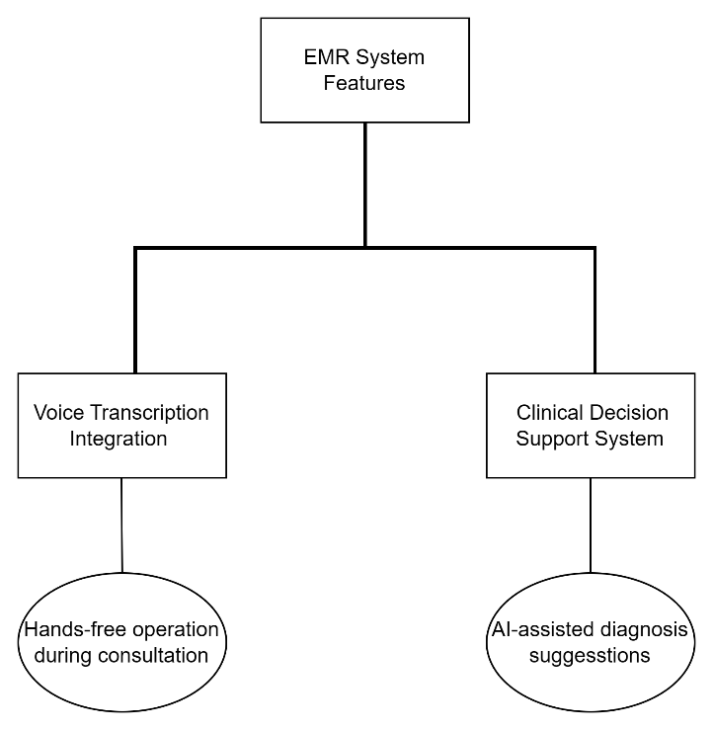

Figure 1: Ideation Mind Map

**7. Prototype Stage: Creating the Prototype**

The **Prototype** was developed to demonstrate how the system would function in a real-world healthcare environment. It integrates innovative features that streamline the medical documentation process and enhance decision-making. The prototype includes:

* **Voice-assisted Data Entry:** Allows healthcare providers to input patient data through voice commands, significantly reducing time and minimizing typing errors.
* **Clinical Decision Support (CDSS):** Offers real-time suggestions for diagnoses and treatment based on the patient’s medical history and current symptoms.
* **User Interface:** A simple, intuitive design that facilitates quick navigation through patient records, ensuring ease of use for healthcare professionals.

**7.1. System Architecture**

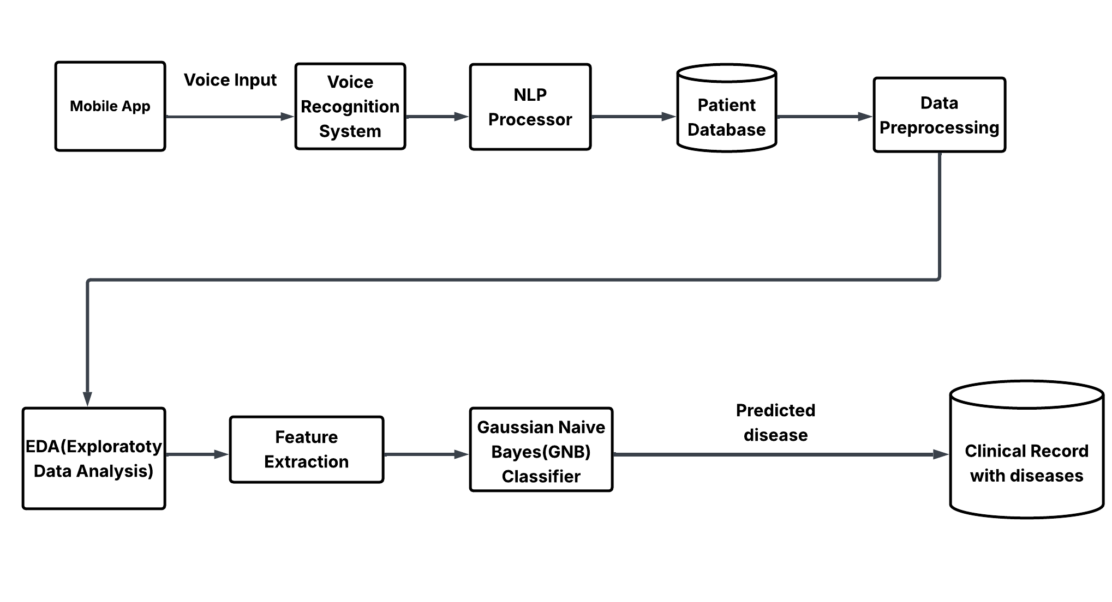

Figure 2: System Architecture

The architecture of our EMR system is designed with the goal of making healthcare workflows easier, faster, and more accurate for clinicians. It integrates modern technologies that work seamlessly together to offer a smooth, user-friendly experience. The system consists of three key parts: the Flutter Frontend (Mobile App), the Firebase Backend, and the Flask-Python Backend. Here’s a breakdown of how everything works together:

**1. Flutter Frontend (Mobile App)**

The user interface is built using Flutter, which allows us to deploy the app on both iOS and Android devices, ensuring wide accessibility for healthcare providers. The frontend includes several important features:

* Login Screen (Firebase Authentication): The login page ensures that only authorized healthcare professionals can access the system. It uses Firebase Authentication to securely log in users.
* Patient Dashboard: After logging in, clinicians are directed to a dashboard where they can quickly see all important information about a patient—medical history, prescriptions, and more. This gives them a comprehensive view in a single place.
* Voice Input (speech_to_text plugin): One of the standout features is the voice input screen. Clinicians can dictate prescriptions and other notes, and the system uses a speech-to-text plugin to convert the spoken words into text. This cuts down on the time spent typing and helps reduce errors, making the system much more efficient and hands-free.

**2. Firebase Backend**

On the backend, Firebase plays a critical role in managing user data and ensuring that everything works smoothly in real-time. Here’s how it helps:

* Authentication: Firebase’s authentication system makes sure that only the right people—clinicians with proper access—can log into the system and view sensitive patient information.
* Firestore (Patient Data): Firestore is used to store all patient data, including medical records, prescriptions, and clinical notes. The real-time database allows quick access to the most up-to-date information.
* Cloud Storage (Audio Files): Firebase’s Cloud Storage is used to store the audio files that are created when a clinician dictates information. These files are used to improve transcription accuracy over time.

**3. Flask-Python Backend**

The Flask-Python Backend is where the system does most of its heavy lifting, processing and analyzing the voice input, running NLP (natural language processing) algorithms, and providing decision support for clinicians:

* Voice Transcription (Google Speech-to-Text): The voice input provided by clinicians is transcribed into text using Google’s Speech-to-Text technology. This ensures that what’s spoken is accurately captured and turned into usable data.
* NLP Processing (spaCy): Once the speech is converted into text, the system uses spaCy, a tool for natural language processing, to extract relevant medical information such as drug names, dosages, and conditions. This ensures that the data is structured and usable within a medical context.
* Clinical Decision Support (TensorFlow Models): The Clinical Decision Support System (CDSS) uses machine learning models built with TensorFlow to analyze the data and provide real-time, evidence-based recommendations. These suggestions may include potential diagnoses, recommended tests, or treatment options, which support clinicians in making more informed decisions.
* RESTful APIs: The different parts of the system communicate with each other through RESTful APIs. These APIs ensure that data flows smoothly between the Flutter frontend, Firebase backend, and Flask-Python backend, making everything work together efficiently.

**How the Components Work Together:**

• **Frontend-Backend Communication:** The Flutter frontend interacts with Firebase for authentication and data storage, and sends voice data to the Flask-Python backend for transcription.

• **Data Flow:** Audio is transcribed via Google Speech-to-Text, processed with spaCy, and analyzed by the CDSS for diagnostic recommendations.

• **Real-Time Updates:** Firestore keeps patient data updated instantly, while Cloud Storage saves audio recordings to enhance transcription accuracy over time.

**7.2. System Workflow and User Interaction**

The user flow of the **Electronic Medical Record (EMR)** system prototype is designed to streamline the medical documentation process, enhance diagnostic decision-making, and simplify prescription creation using modern technologies such as **voice transcription** and **Clinical Decision Support System (CDSS)**. The following breakdown outlines the user interaction once they log in:

**User Login and Dashboard:**

Upon successfully logging into the application through a secure authentication process, users (e.g., doctors or healthcare providers) are directed to the main **Dashboard**. The dashboard is the central hub of the system, offering two primary tabs for navigation: **Transcription** and **CDSS (Clinical Decision Support System)**. Each tab leads to distinct functionalities aimed at improving workflow efficiency in patient care.

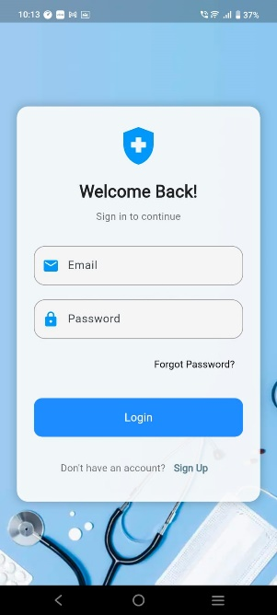 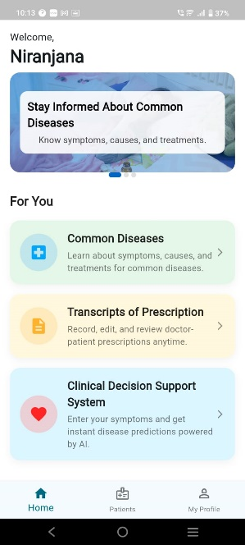

Figure 3: Login Page Figure 4: Dashboard Page

**Transcription Feature and Patient Profile:**

When the user clicks on the **Transcription Tab**, they are redirected to a **Patient Profile Page**. This page lists all patients within the healthcare system’s records. Users can select a patient's profile for further interaction.

**User Actions on the Patient Profile Page:**

* 1. **Selecting a Patient Profile:** The user clicks on a patient's profile to access detailed information, such as medical history, previous prescriptions, and relevant clinical data.
  2. **Creating a Prescription:** Using the integrated **Voice Transcription** feature, healthcare providers can dictate prescriptions for the selected patient. The system converts the voice input into text in real-time, drastically reducing manual data entry.
  3. **Saving the Prescription:** Once the prescription is dictated, the user can review the transcribed content, make necessary adjustments, and save it to the patient's profile for future reference and tracking.This feature enables healthcare professionals to create accurate prescriptions without having to manually type out each entry, leading to faster documentation, reduced administrative burdens, and a more streamlined workflow.

***Figures 5-7*** illustrate the transcription page and its key functionalities.

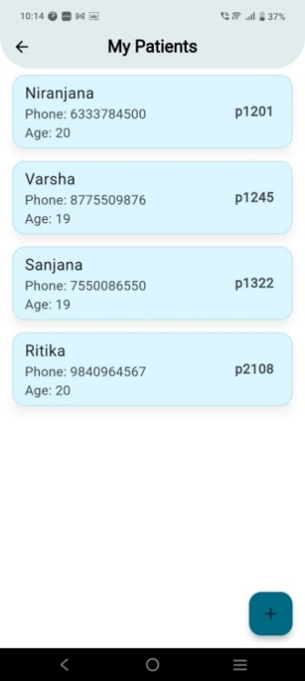 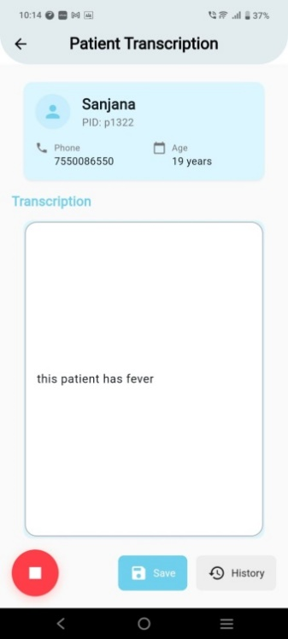

Figure 5: Patient Profiles Page Figure 6: Transcription Page

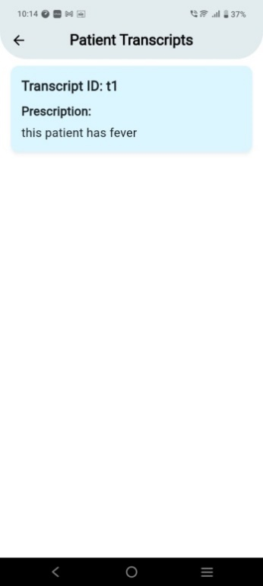

Figure 7: Patient Transcripts Page

**CDSS Feature (Clinical Decision Support System):**

Alongside the voice transcription feature, the dashboard includes another incredibly helpful tool: the Clinical Decision Support System (CDSS). This feature is designed to assist healthcare providers by offering real-time diagnostic suggestions based on the symptoms they enter. By providing evidence-based recommendations, the CDSS helps improve decision-making, reduce diagnostic errors, and ultimately enhance patient care.

**How Clinicians Interact with the CDSS:**

1. **Selecting the CDSS Tab:** The process starts when the clinician clicks on the CDSS tab located on the dashboard. It's easy to find, so they can quickly access it when they need it. Once clicked, it leads them to a page where they can input the patient’s symptoms.
2. **Entering Symptoms:** The symptom input page is designed to be simple and flexible. The clinician can either type the symptoms directly or select from a list of common medical conditions. This is helpful because it lets the clinician either be specific with their input or browse through a list to consider a wider range of possible conditions. It saves time, reduces the chance of missing anything, and makes sure the system captures a full set of relevant details. Whether the clinician knows exactly what they're looking for or needs some guidance, this flexibility makes it easier to input accurate data.
3. **Getting Diagnosis and Suggestions:** After entering the symptoms, the system works its magic, using advanced algorithms to analyze the data and offer diagnostic suggestions in real time. These suggestions might include potential diagnoses, tests to consider, or treatment options. The system continuously updates itself with the latest medical knowledge, so it’s always working with the most current and relevant information. This gives clinicians a set of informed recommendations to consider during patient interactions, helping them make more confident, evidence-based decisions.

***Figures 8 and 9*** illustrate the CDSS page and its key functionalities.

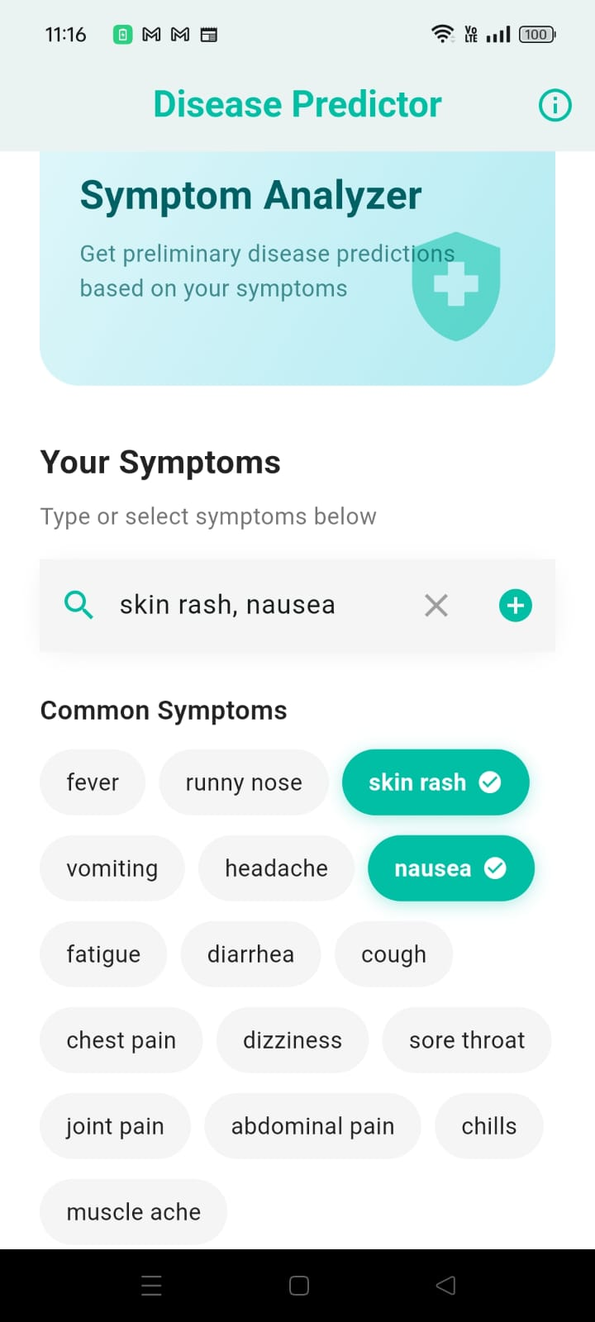

Figure 8: CDSS Input Page

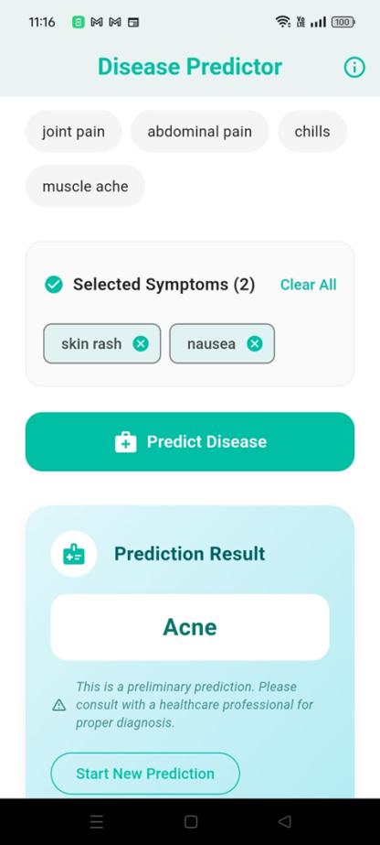

Figure 9: CDSS Output Page

**Seamless Integration of Features:**

The prototype is designed to provide a seamless user experience, combining **voice-powered transcription** with **AI-driven decision support** in one unified platform. After logging in, users can easily switch between the **transcription** and **CDSS** features, enabling them to efficiently handle patient data and make informed decisions quickly.

* **Transcription Feature:** Saves valuable time by allowing fast and accurate prescription creation.
* **CDSS:** Enhances clinical decision-making by offering real-time diagnostic suggestions based on entered symptoms.

Both features are integrated into the patient workflow, ensuring healthcare providers can perform necessary tasks without leaving the system or switching between multiple applications.

**8. Test and Feedback: Iterative Testing and Refinement**

The development process for the EMR system has been guided by continuous testing and feedback loops. This iterative approach focuses on improving functionality, user experience, and aligning with healthcare professionals' needs.

**8.1. Initial Prototype and Feedback Collection**

The first version of the EMR system included fundamental features like patient record management, voice transcription, and the basic clinical decision support system (CDSS). Feedback from healthcare professionals and the project mentor was collected during the initial testing phase.

**Key Feedback from Testing:**

* **Healthcare Professionals (Doctors and Staff):**
  + **Voice Transcription:** While the feature was useful, issues arose with transcription accuracy, particularly concerning medical terminology. Healthcare professionals asked for improvements to handle transcription errors more effectively.
  + **Offline Functionality:** The need for offline capabilities was emphasized, especially for professionals working in areas with unreliable internet connections.
  + **UI Navigation:** Although the interface was simple, users suggested adding a quick-access menu to improve navigation and efficiency.
* **Feedback from Project Mentor:**
  + **Usability:** The mentor appreciated the system’s simplicity but recommended faster access to essential features, particularly in urgent healthcare environments.
  + **Voice Transcription Accuracy:** Emphasis was placed on improving transcription accuracy for medical contexts.
  + **Recommendation System:** The mentor suggested incorporating an AI-driven recommendation system in the CDSS to provide real-time insights and assist healthcare providers in making more informed decisions.

**8.2. Refinement Based on Feedback**

In response to the feedback we received from healthcare professionals, several key improvements were made to enhance the functionality and usability of the EMR system, ensuring it better meets the needs of clinicians.

One of the most notable upgrades was in the voice transcription feature. We focused on improving the accuracy of transcribed text, especially when recognizing medical terminology. This was a critical enhancement, as healthcare providers often rely on precise and clear transcription to document patient information. By refining the speech recognition algorithms and incorporating more medical-specific vocabularies, transcription errors were significantly reduced. This update made the system more reliable, helping clinicians to confidently use voice input during their patient consultations without worrying about errors in transcribed information.

In addition to transcription improvements, user interface (UI) enhancements were prioritized. We introduced a quick-access menu that streamlines navigation, allowing clinicians to rapidly access frequently used features such as patient records and prescriptions. Given the high-pressure, time-sensitive nature of healthcare settings, this change was designed to make the system more intuitive and responsive. It helped reduce the time spent searching for information, ultimately allowing healthcare professionals to focus more on patient care and less on navigating through complex menus.

These updates, driven by direct feedback from users, are part of our ongoing commitment to making the EMR system as efficient, accurate, and user-friendly as possible. By continuously refining these features, we aim to enhance clinical workflows, reduce administrative burdens, and ultimately improve patient care.

**8.3. A Continuous Improvement Cycle**

The development of the EMR system has been an ongoing journey of testing, refining, and adapting to meet the real-world needs of healthcare professionals. The iterative process has been absolutely crucial in shaping the system to be as efficient and user-friendly as possible, ensuring that it truly supports clinicians in their daily work. With each round of feedback, the system was enhanced to better serve its users, and this feedback loop has been central to the success of the project.

One of the most significant improvements made was in **transcription accuracy**. Voice transcription is a key feature of the system, and it was essential that the transcriptions be as accurate as possible to ensure that the information being input into the system was reliable. Healthcare professionals rely on accurate documentation to provide the best care possible, and a minor error in transcription can lead to serious consequences. To address this, we focused on improving the system's ability to recognize medical terminology and reduce transcription errors. The system now delivers more accurate voice-to-text conversions, which not only saves time for clinicians but also reduces the risk of mistakes, allowing them to focus more on patient care and less on correcting data.

Along with transcription improvements, **user interface (UI) enhancements** were a major focus. The feedback from clinicians revealed that while the system was functional, some parts of the interface felt unintuitive or too complex for quick, efficient navigation. In response, we introduced a **quick-access menu** that allows users to easily navigate to frequently used features such as patient records, prescriptions, and appointment scheduling. This simple yet impactful change ensures that healthcare providers can quickly access the tools they need in high-pressure, time-sensitive environments. The updated UI has been widely appreciated for making the system more intuitive, allowing clinicians to spend less time searching for information and more time with their patients.

Despite these improvements, the system is still a work in progress. **Offline functionality** and the **recommendation system** are key features that are currently under development. Clinicians have expressed the need for a more robust offline mode, especially in environments where internet connectivity may be unreliable or unavailable. We’re actively working on this feature to ensure that healthcare providers can continue to use the system effectively, regardless of their location or network availability. Additionally, the **clinical decision support system (CDSS)** is being enhanced to provide even more accurate and personalized recommendations based on real-time patient data. The goal is to create a system that not only records and stores patient information but also actively supports clinicians by offering evidence-based suggestions that can guide decision-making and improve patient outcomes.

Looking ahead, the **ongoing feedback collection** process will continue to be an essential part of the system’s development. Clinicians, nurses, and administrative staff are the ones who truly understand the challenges of daily healthcare workflows, and their input is invaluable in ensuring that the system evolves in ways that directly benefit them. With each piece of feedback, we can make further refinements, adding new features, optimizing existing ones, and improving overall system performance.

Ultimately, our commitment to continuous improvement means that the EMR system will always be evolving to meet the needs of healthcare providers. By focusing on improving transcription accuracy, UI usability, and expanding key features, we aim to make the system an indispensable tool for clinicians. With the ongoing development of features like offline functionality and the recommendation system, we are confident that the EMR will become even more integrated into healthcare workflows, aiding decision-making and, most importantly, enhancing patient care. The future of the EMR system holds great promise, and we are excited about the impact it will have on healthcare delivery.

**9. Re-design and Implementation**

After incorporating feedback-driven improvements, the redesigned prototype was tested again to ensure it met the real-world needs of healthcare professionals. The results were promising—the system successfully addressed the key challenges identified in earlier phases, providing a more seamless experience for users.

The voice-enabled data entry feature, which was a core element of the redesign, now works with much greater accuracy, allowing clinicians to input patient information quickly and efficiently. This eliminates the need for extensive manual typing, saving valuable time and reducing the chance for errors. Clinicians can now focus more on patient care rather than on cumbersome administrative tasks.

Another significant upgrade is the integration of **real-time clinical decision support**. By offering immediate, evidence-based suggestions and recommendations during patient encounters, the system provides clinicians with an extra layer of support. Whether it’s a diagnostic suggestion or guidance on treatment options, the CDSS helps ensure that decisions are informed by the most current medical knowledge, ultimately improving patient outcomes.

Perhaps one of the most requested features was the **offline functionality**. Healthcare professionals working in areas with unreliable or no internet connectivity can now continue using the system without interruptions. This ensures that essential data entry and decision support capabilities are always available, regardless of network status.

Overall, the redesigned prototype is a significant improvement, effectively meeting the identified needs of users and setting the stage for continued development. It not only enhances the efficiency of healthcare workflows but also ensures that clinicians have the tools they need to provide the best care possible, even in challenging environments.

**10. Conclusion**

The project successfully applied the **Design Thinking** methodology to create a user-centered **Electronic Medical Record (EMR)** system, focusing on solving some of the most pressing issues in healthcare. By addressing the challenges of time-consuming data entry and the lack of real-time decision support, the system offers a significant improvement in healthcare efficiency, helping clinicians deliver better care while reducing administrative burdens.

One of the standout features is the **voice transcription** capability. Clinicians often spend a substantial amount of time manually entering patient data into the system, which not only takes away from the time they can spend with patients but also increases the likelihood of errors. The integration of **voice input** allows healthcare providers to dictate patient information quickly and accurately, making the process faster and more reliable. This feature, designed with the clinician’s workflow in mind, alleviates a significant pain point for many users.

The **clinical decision support (CDS)** system is another major advancement. The system delivers real-time, evidence-based recommendations directly to healthcare providers as they interact with the EMR. By offering suggestions about diagnoses, treatments, or potential risks, the CDS helps clinicians make informed decisions quickly, which can have a direct impact on patient care. It reduces the time needed to access vital information, which is particularly important in fast-paced clinical environments.

Overall, the project represents a substantial leap forward in the evolution of EMR systems. By addressing the core issues of data entry and decision support, and by focusing on usability and efficiency, this system empowers healthcare professionals to work smarter, not harder. Ultimately, it aims to improve both the clinician experience and patient outcomes, creating a more seamless and effective healthcare process.

**11. Future Work**

The EMR system aims to expand its capabilities in two key areas. **First**, it plans to integrate wearable health devices, such as fitness trackers and medical-grade monitors, to enable continuous, real-time monitoring of patient vitals like heart rate, blood pressure, and glucose levels. This integration will support proactive care by providing healthcare professionals with immediate alerts for significant changes in a patient's condition, facilitating early intervention and personalized care. **Second**, the system will enhance its voice transcription feature to support multiple languages, making it more accessible to users in diverse regions. This improvement will reduce language barriers, improve documentation accuracy, and ensure seamless communication between healthcare providers and patients.

**12. Learning Outcome of Design Thinking**

Throughout this project, we’ve gained valuable insights into the Design Thinking process, which has truly shaped the development of our EMR system. Each step, from empathy to iteration, has taught us important lessons that will guide future projects and improvements.

First and foremost, empathy has been a game-changer in identifying the real challenges faced by healthcare professionals. By stepping into the shoes of our users, we were able to understand their frustrations, needs, and workflows, which helped us pinpoint key areas for improvement. This user-centered approach ensured that we weren’t just building a system for the sake of technology, but one that genuinely addressed the pain points of those who would use it daily.

Another lesson was the power of iterative prototyping. Early versions of the system were far from perfect, but through constant testing and gathering feedback, we could refine and improve the design. Each cycle of testing allowed us to uncover new insights and make incremental changes, which ultimately resulted in a more user-friendly, functional product. This approach reinforced the importance of not waiting for perfection before launching, but rather embracing continuous improvement.

Collaboration also played a crucial role in our success. We learned that working closely with healthcare professionals, project mentors, and team members brought different perspectives that enriched the process. Open communication and shared goals made it possible to align the system’s development with real-world needs.

Finally, we realized that Design Thinking is cyclical. It’s not a one-and-done process but rather an ongoing journey. As new challenges arise or users provide fresh feedback, the system will continue to evolve, ensuring that it remains effective and responsive to changing needs. This mindset of continual refinement is something we’ll carry forward in all future projects.

**References**

[1] J. Zhang and D. Chang, "Semi-Supervised Patient Similarity Clustering Algorithm Based on Electronic Medical Records," IEEE Access, vol. 7, pp. 90705-90714, 2019, doi: 10.1109/ACCESS.2019.2923333.

[2] M. Gil, R. El Sherif, M. Pluye, B. C. M. Fung, R. Grad and P. Pluye, "Towards a Knowledge-Based Recommender System for Linking Electronic Patient Records With Continuing Medical Education Information at the Point of Care," IEEE Access, vol. 7, pp. 15955-15966, 2019, doi: 10.1109/ACCESS.2019.2894421.

[3] S. R. Abidi, C. Y. Han and S. R. Abidi, "Patient empowerment via ‘pushed’ delivery of personalised healthcare educational content over the Internet," Stud. Health Technol. Inform., vol. 84, pp. 1425-1429, 2001.

[4] D. W. Bates et al., "Ten commandments for effective clinical decision support: Making the practice of evidence-based medicine a reality," J. Amer. Med. Inform. Assoc., vol. 10, no. 6, pp. 523-530, 2003.

[5] A. C. Valdez, M. Ziefle, K. Verbert, A. Felfernig and A. Holzinger, "Recommender systems for health informatics: State-of-the-art and future perspectives," in Machine Learning for Health Informatics, Cham, Switzerland: Springer, pp. 391-414, 2016.

[6] Anibal J, Huth H, Li M, Hazen L, Daoud V, Ebedes D, Lam YM, Nguyen H, Hong PV, Kleinman M, Ost S, Jackson C, Sprabery L, Elangovan C, Krishnaiah B, Akst L, Lina I, Elyazar I, Ekawati L, Jansen S, Nduwayezu R, Garcia C, Plum J, Brenner J, Song M, Ricotta E, Clifton D, Thwaites CL, Bensoussan Y, Wood B. Voice EHR: introducing multimodal audio data for health. Front Digit Health. 2025 Jan 28;6:1448351.

doi: 10.3389/fdgth.2024.1448351. PMID: 39936096; PMCID: PMC11812063.

[7] Wong, Jenna, Mara Murray Horwitz, Li Zhou, and Sengwee Toh. "Using machine learning to identify health outcomes from electronic health record data." Current epidemiology reports 5 (2018): 331-342.

[8] Ford, Elizabeth, et al. "Extracting information from the text of electronic medical records to improve case detection: a systematic review." Journal of the American Medical Informatics Association 23.5 (2016): 1007-1015.

[9] Xia, Xin, et al. "An online intelligent electronic medical record system via speech recognition." International Journal of Distributed Sensor Networks 18.11 (2022): 15501329221134479.

[10] S. Saha, "The new age electronic patient record system," Proceedings of the 1995 Fourteenth Southern Biomedical Engineering Conference, Shreveport, LA, USA, 1995, pp. 134-137,

doi: 10.1109/SBEC.1995.514459.